Step 1-Install acquia without changing port of apache n mysql

Step2-create a local folder in which you want your code

Step3-open git bash/cmd in the same folder clone the repository from pantheon(let say clone folder name is “MYWEBSITE”)

Step4-download database and files from pantheon

Step 5-open Acquia dev desktop

1. Method 1 –add drupal site locally present in your computer Or

Method2-click on + button

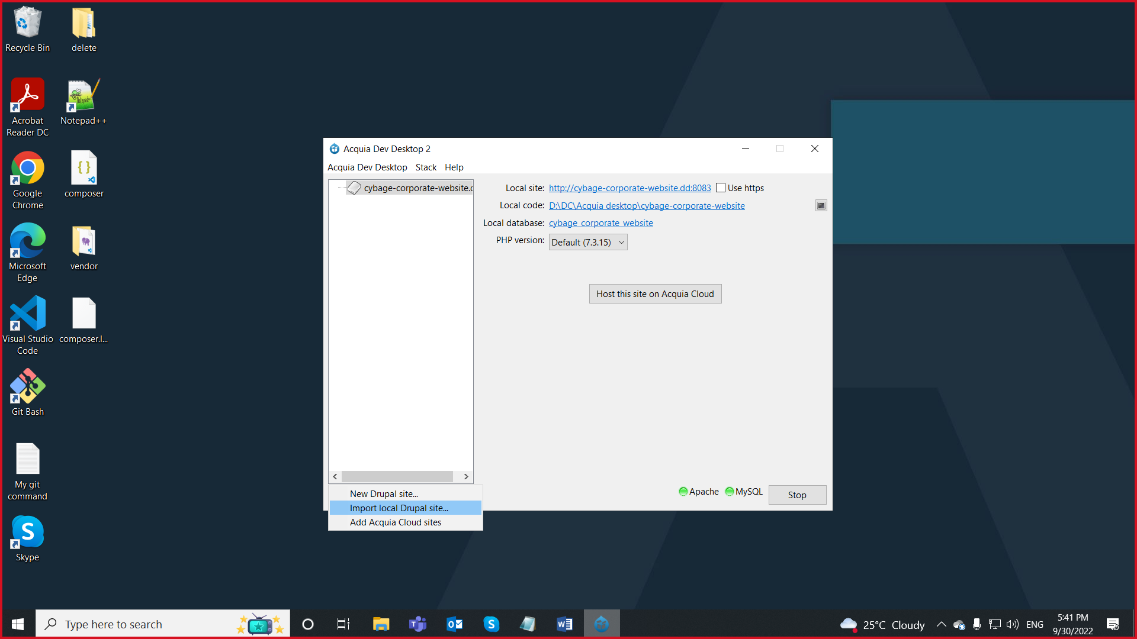

Step6-select the local folder which you have clone from pantheon and select the respective database .gz file also use default php version and press Ok button

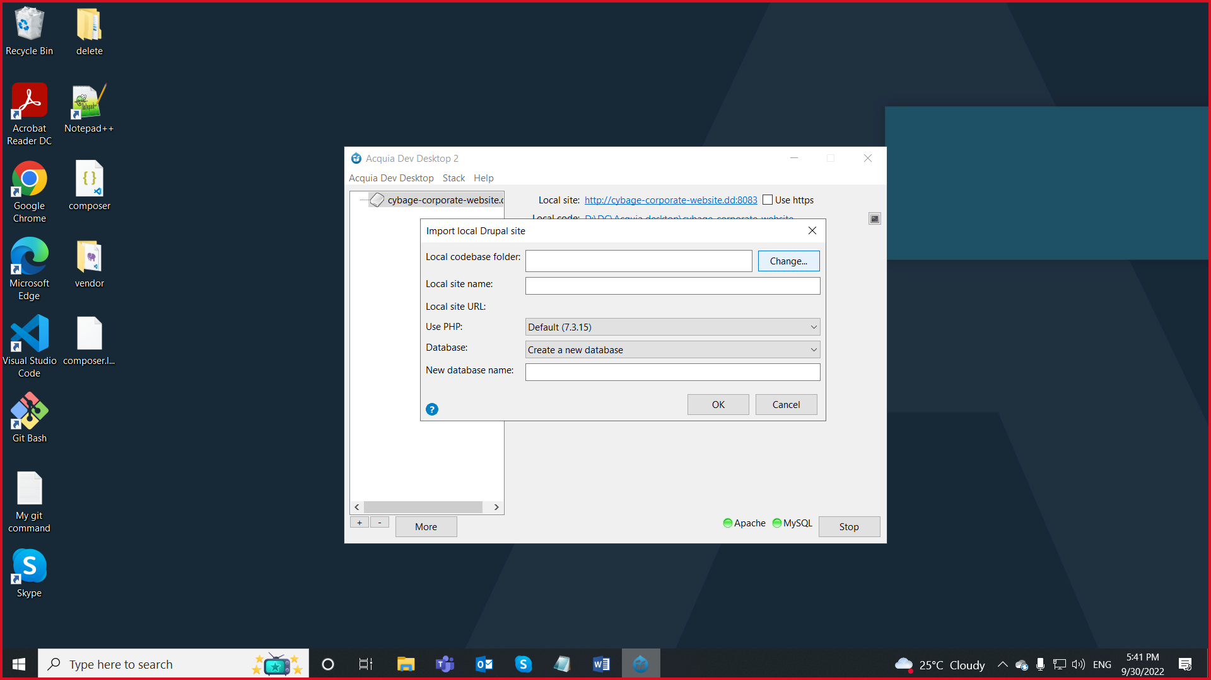

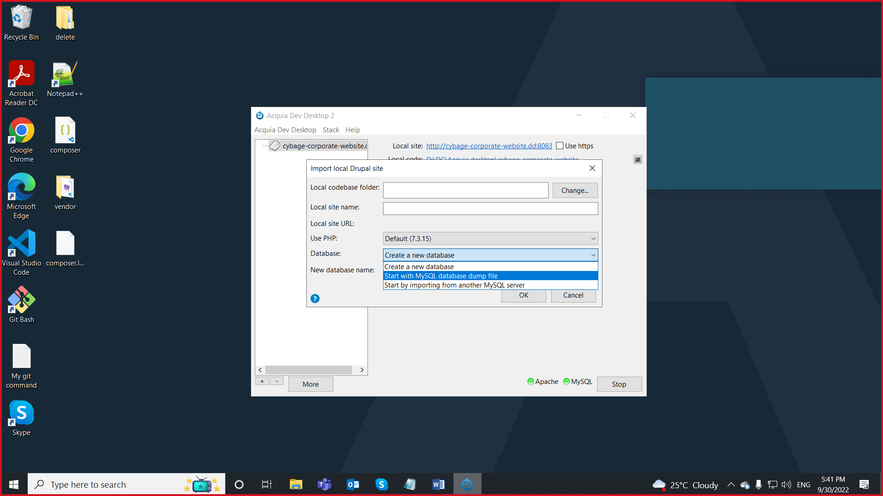

(let say clone folder name is “MYWEBSITE”)

Step7-goto- MYWEBSITE-sites

select example.settings.local copy this file and paste in

MYWEBSITE-sites-default folder by name settings.local

Now add following code to settings.local on last line

$settings['hash_salt'] = 'cybage_corporate_website';

$databases['default']['default'] = array(

'driver' => 'mysql',

'database' => 'cybage_corporate_website',

'username' => 'root',

'password' => '',

'host' => '127.0.0.1',

'port' => 33067 );

Note-check database credentials and ports

Step8-goto- MYWEBSITE-sites-default

Open settings.php and add following code to last line of the file

ini_set('max_execution_time', 0);

Step9- goto-MYWEBSITE-sites-default

Delete file name by “files” and create a folder with name “files”

goto downloaded file(containing media files) from pantheon extract that till we get the folder structure copy all the folder inside that file and paste them in “files” folder

Step10-hit the link on acquia n check the browser